Experiment
Creating and Analyzing Disk Images Using dc3dd and Autopsy (Alternative to FTK Imager)

1. Aim
To create a forensic disk image and analyze digital evidence using dc3dd and Autopsy in Kali Linux.

2. Objectives
After completing this experiment, students will be able to:
- Understand the concept of digital forensics and disk imaging
- Create a bit-by-bit forensic copy of a storage device
- Maintain data integrity using hashing
- Analyze disk images to identify files, deleted files, and system artifacts

3. Introduction / Theory

Digital Forensics
Digital forensics is the process of identifying, collecting, preserving, analyzing, and presenting digital evidence from computers or storage devices.
Digital evidence may include:
- Documents
- Emails
- Browser history
- Logs
- Deleted files
To preserve evidence, investigators create a forensic disk image.

Disk Imaging
Disk imaging is the process of creating an exact replica of a storage device.
Characteristics of forensic disk images:
- Bit-by-bit copy of storage
- Preserves deleted files
- Maintains data integrity
- Allows investigation without altering original evidence

Hashing in Forensics
Hashing is used to verify the integrity of digital evidence.
Common hash algorithms:
Algorithm | Purpose
MD5 | evidence integrity
SHA1 | verification
SHA256 | stronger security
If the hash value of the original disk and the disk image match, the evidence is considered intact.

4. Tools Used
Tool | Purpose
Kali Linux | forensic analysis environment
dc3dd | disk image acquisition
Autopsy | forensic investigation and analysis

5. System Requirements
Component | Specification
Processor | Intel i3 or higher
RAM | Minimum 4 GB
Disk | 20 GB free space
Software | Kali Linux VM

6. Algorithm
- Start the Kali Linux environment.
- Generate activity on the system to create forensic artifacts.
- Identify the disk partition using system commands.
- Create a forensic disk image using dc3dd.
- Generate hash values for integrity verification.
- Start the Autopsy forensic analysis tool.
- Import the disk image into Autopsy.
- Analyze files, logs, and deleted artifacts.
- Extract relevant digital evidence.

7. Procedure

Step 1: Open Terminal in Kali Linux
Press:
Ctrl + Alt + T
This opens the terminal.

Step 2: Create Sample Evidence
Generate a file that will later be discovered during forensic analysis.
echo "Cybersecurity Lab Evidence" > evidence.txt
Verify the file creation.
Ls

Step 3: Identify Disk Partition
List storage devices.
lsblk
Example output:
sda
├─sda1
├─sda2
The partition /dev/sda1 will be used for disk imaging
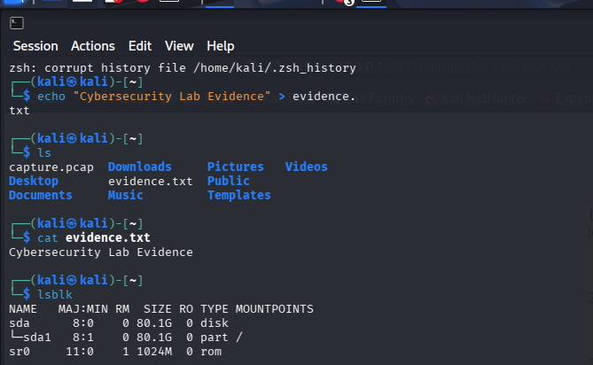

Install dc3dd
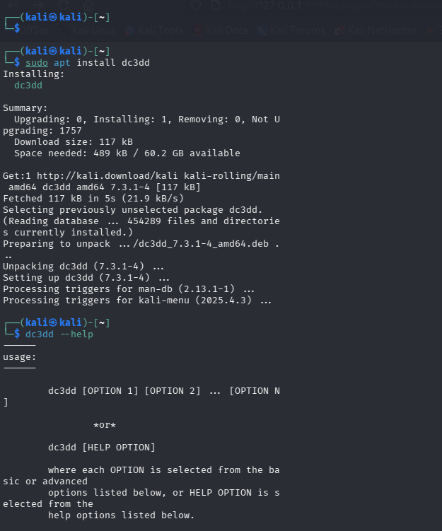

Step 4: Create Disk Image

Step 1: Create a Small Disk File
dd if=/dev/zero of=practice_disk.dd bs=1M count=100

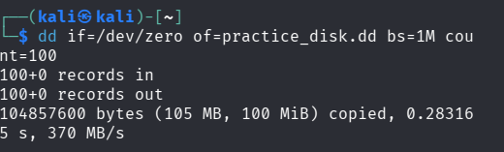

Explanation:
Parameter | Description
if | input disk
of | output image file
hash | generate MD5 hash
log | acquisition log file

Creates a 100 MB disk.

Step 2: Mount the Disk
mkfs.ext4 practice_disk.dd
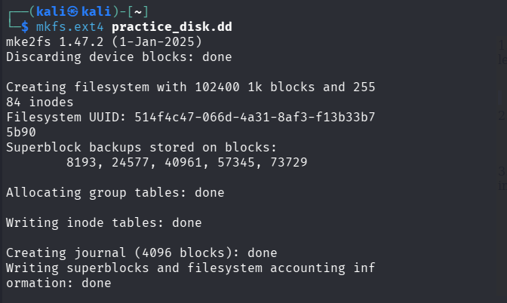

Step 5: Verify Image Creation
Check the created image.
ls -lh /home/kali/disk_image.dd

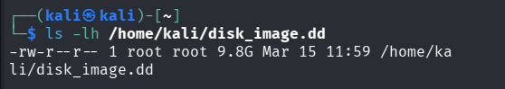
Check log file.
cat /home/kali/acquisition.log
The log will contain:
- image size
- hash value
- acquisition details
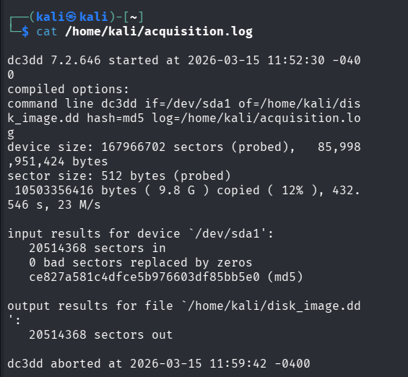

Step 6: Start Autopsy
Launch the forensic analysis tool.
Autopsy

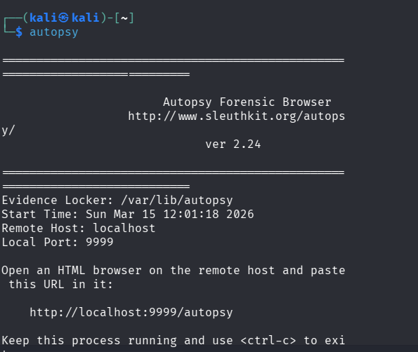

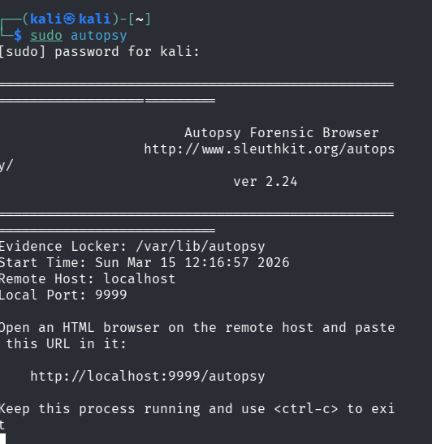
The terminal will display a URL:
http://localhost:9999/autopsy
Open this link in the browser.

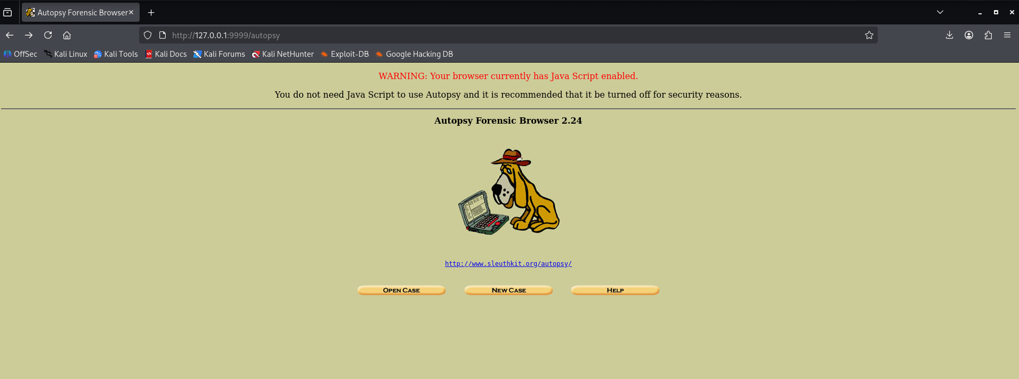

Step 7: Create a New Case
In the Autopsy interface:
- Click Create New Case
- Enter case details:

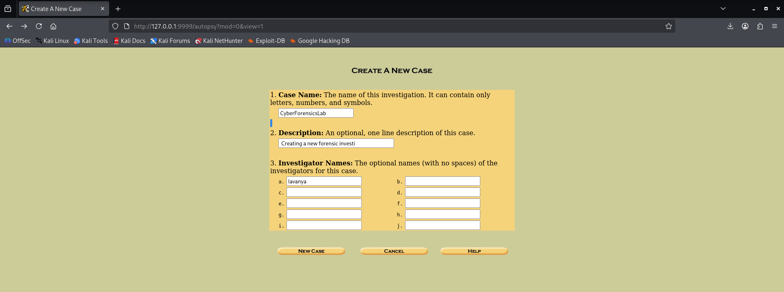

Step 8: Add Disk Image
Select:
Add Host → Add Image
Browse and select:
/home/kali/disk_image.dd
Autopsy will begin analyzing the disk image.

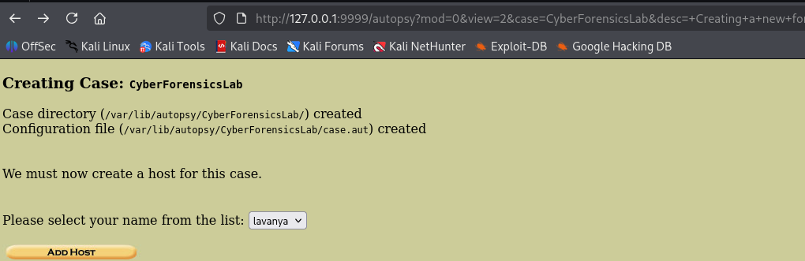

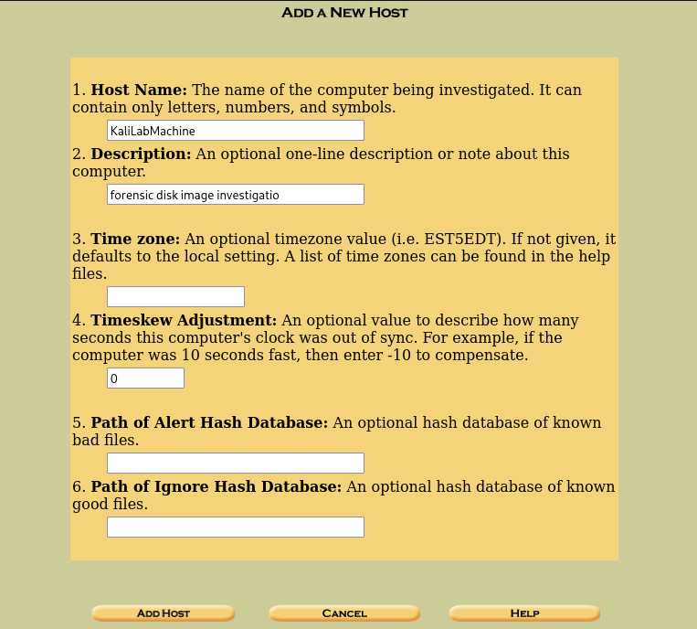

Recommended Values
Host Name
KaliLabMachine
Description
Kali Linux virtual machine used for forensic disk image investigation
Time Zone
Leave Blank
Time Skew Adjustment
Leave Blank
Alert Hash Database
Leave Blank
Ignore Hash Database
Leave Blank
Then click:
Next

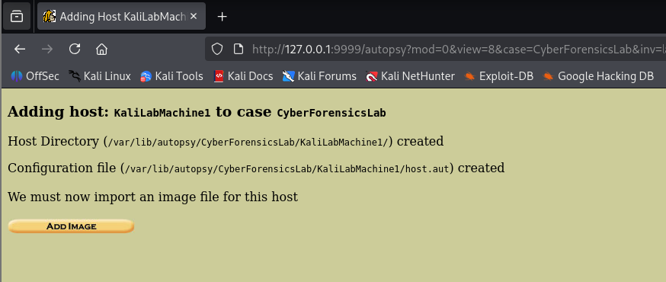

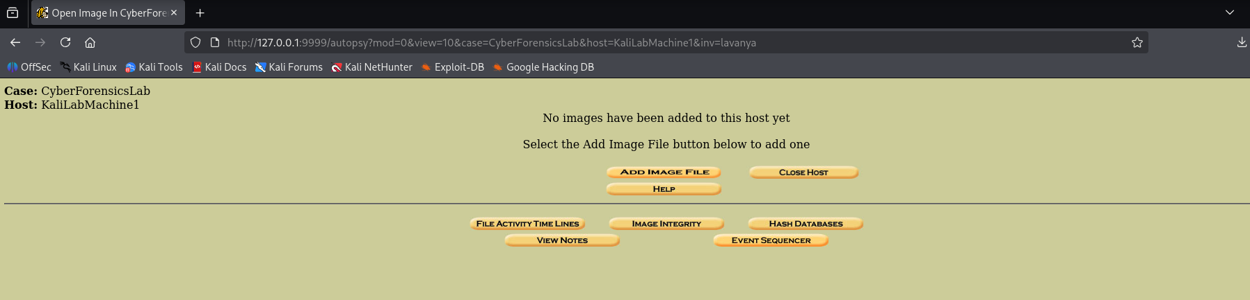

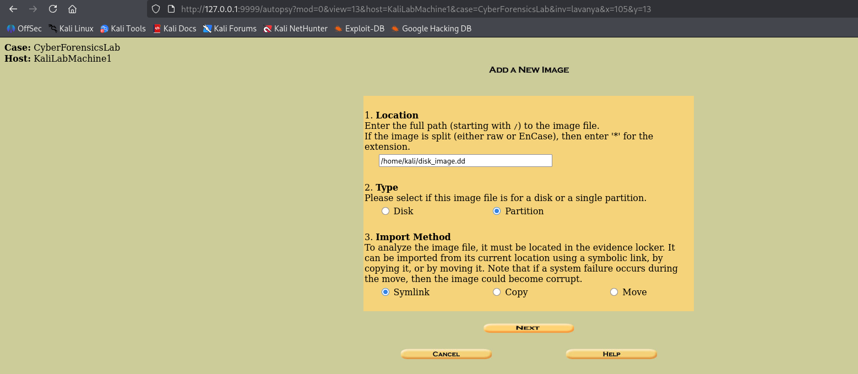

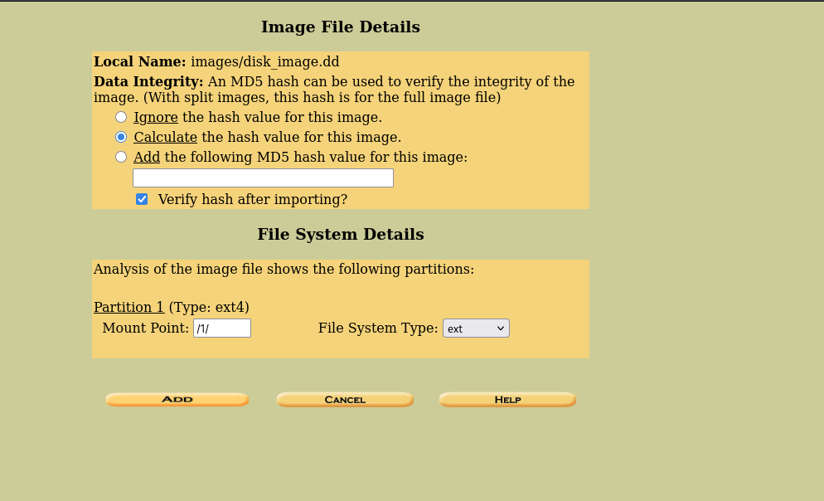

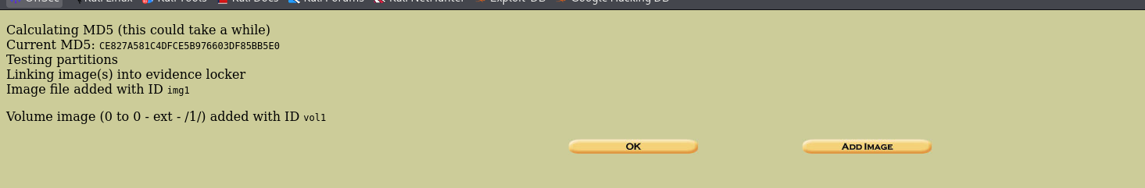

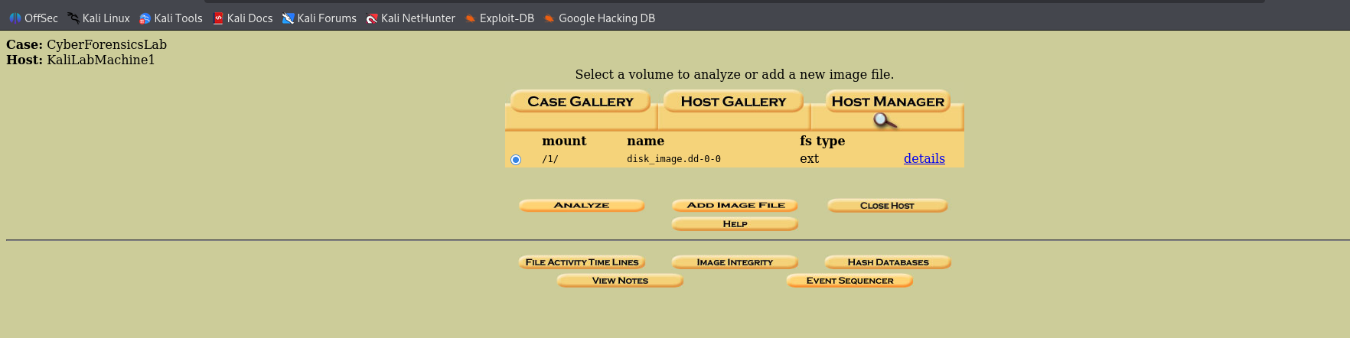

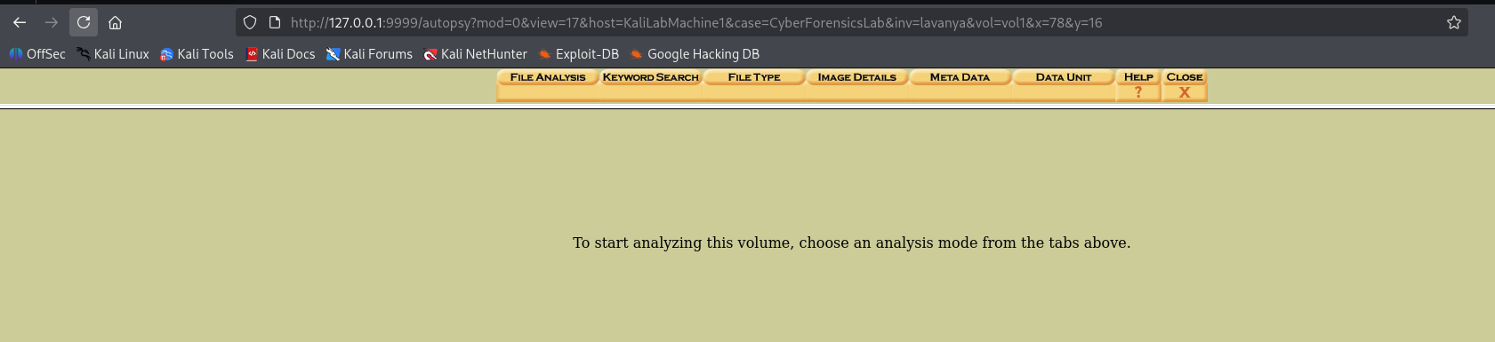

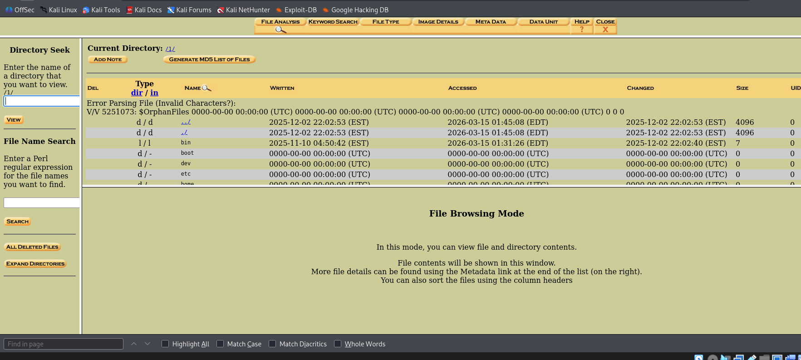

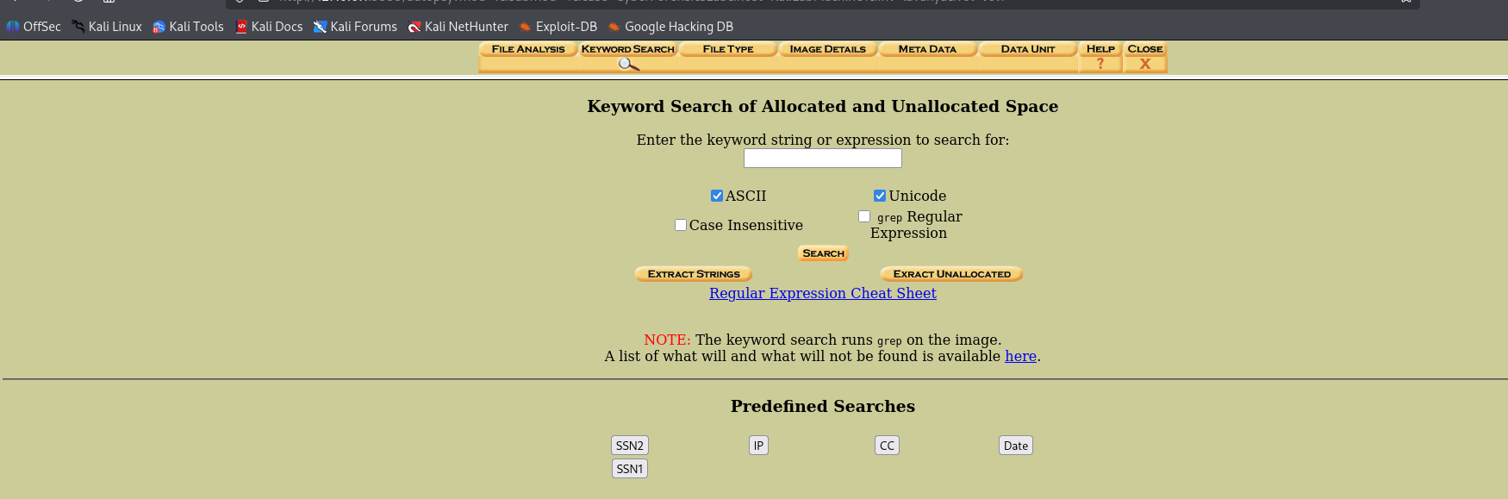

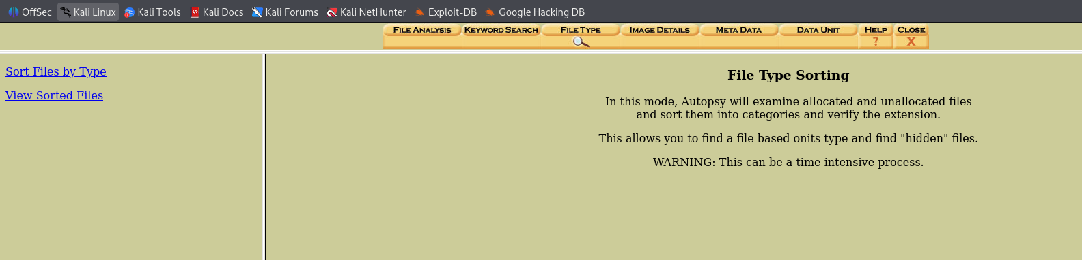

Step 9: Analyze Evidence
